Real-Time Process Scheduling

David Graves
Colorado State University Global
CSC507
Dr. Joseph Issa
August 22, 2025

Real-Time Processing
Manipulating and processing large datasets is becoming more important every day as more companies look to Machine Learning and Big Data to provide meaningful analysis to drive innovation and solutions to complex problems. This is already at the forefront of many leader’s minds across industries where “Big Data initiatives were rated as ‘extremely important’ to 93% of companies”. (Techvidvan, n.d.) This reinforces the need to provide reliable and efficient real-time processing solutions today, and to that end it’s helpful to gain a better understanding of how to manipulate large data sets to provide solutions to those leaders. I’ll use the remainder of this paper exploring different Python scripts and their efficiency, measured in time, to execute the task of taking a large text file including 10 million random as input, multiplying it by 2 and producing one output file with the product of the task. I’ll share five initial cases including running the process as is, then splitting the input into different equal file sizes of 2, 5, 10, 20 files prior to execution.
Testing for efficiency
Prior to running this exercise, I created a massive file ‘10milfile.txt’ shown in Image 1 below including 10 million lines of random numbers that I could use as input across all attempts.
Image 1 – 10 million lines of random numbers file
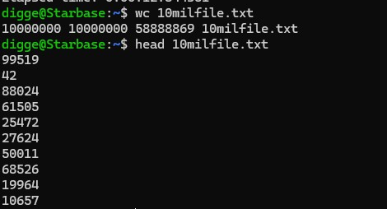
The first approach I’ll review for efficiency is splitting the input file into different sizes and processing sequentially. Stallings (n.d) notes, “Sequential files are typically used in batch applications and are generally optimum for such applications”, so that seems like a reasonable place to start. I established a real-time processing baseline by running the script ‘as-is’ without splitting it first, and the results are displayed below in Image 2. The script properly executed doubling the initial big file in 11.9771 seconds.
Image 2 – Process as is
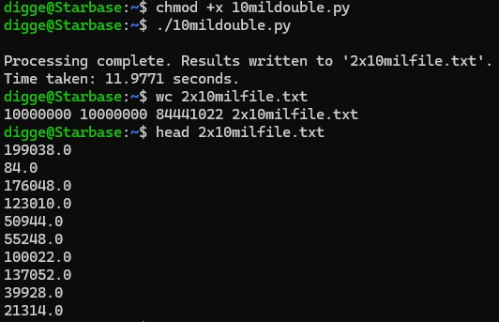
Next, I created a new script to split the initial file and used it for all the different splits substituting the division of the initial file prior to running. I’ve included Image 3 below validating that the 2-way split executed the script and successfully doubled the values in 12.25 seconds. I’ve shown all the other split values time to execution in Table 1 below as well for easy comparison. As seen, all execution times were reasonably close with ‘no splitting, or as-is’ performing the fastest with time increasing as the initial split sizes grew. This was an interesting result and leads me to believe that the overhead introduced by splitting the files didn’t provide a net benefit and in fact may have bogged program execution down a hair.
Image 3 – 2-way split
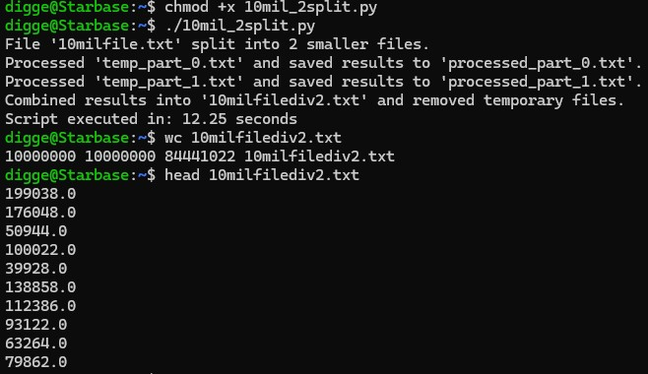
Table 1 – Times to execution
Script Approach | Time to execute
As is, no splitting | 11.98 seconds
Split initial file in 2 | 12.25 seconds
Split initial file in 5 | 12.46 seconds
Split initial file in 10 | 14.33 seconds
Split initial file in 20 | 12.78 seconds

With these results in mind, I decided to try a couple other execution methods to try and increase speed leveraging ‘NumPy’, ‘pandas’, and multiprocessing because “multiprocessing offers several benefits, including faster task execution”. (Lenovo, n.d) I created three new scripts in Python to execute the same task using those three concepts and have displayed their results below in Table 2.
Table 2 – Times to execution
Script Approach | Time to execute
NumPy | 59.55 seconds
Pandas | 17.39 seconds
Multiprocessor | 22.59 seconds

These were interesting results yet not fully unexpected since the basic ‘as-is’ approach from earlier seemed to perform the best, leading me to believe that some of these more involved processes may not be super successful. Again, I think what I ran into especially with NumPy is overhead where it leverages indexing methods that aren’t overly beneficial with simple string operations. Pandas performed better than the other two, but still not better than just running the script ‘as-is’ from the original experiment. Leveraging multiprocessing didn’t do as well either, which could be due to Inter-Process Communication costs especially in aggregating the data.
Reflection
In reflecting on this exercise, I came away with the conclusion that although there are many ways to manage a task like this, the straightforward less complicated script performed the best with a couple caveats. Although the input file was large (10 million rows) the operation for each line was simple, so the overhead associated with splitting and the other more ‘exotic’ scripts didn’t provide benefit. Another consideration is the memory availability, where with my machine it looks like there weren’t any issues with executing line by line. I think one reasonable approach to increasing speed with simple processing tasks involving massive data sets would be to ensure that the input file and data are clean and well organized. It wouldn’t have helped in this case, but if the input file had 20 columns of data and we just needed one column of information to process, speed could possibly be gained by eliminating unnecessary data prior to running the scripts. Although none of my additional attempts were better, I’m happy that I tried these approaches, because it helped me to learn what does and doesn’t work for future cases where the most simple or straightforward approach may not be the best and I’ll need to use other processing approaches.

References
Lenovo (n.d) Lenovo.com. What is Multiprocessing?
https://www.lenovo.com/us/en/glossary/multiprocessing/?orgRef=https%253A%252F%252Fwww.google.com%252F
Stallings, W. (n.d.). Operating Systems: Internals and Design Principles, 9/e.
Retrieved from https://platform.virdocs.com/read/2228445/126/#/4/2[P700101386900000000000000000463D]/24[P7001013869000000000000000004665]/6[P700101386900000000000000000E10F],/1:0,/1:0
Techvidvan (n.d). Techvidvan.com. Why Big Data – Benefits and Importance of Big Data.
Why Big Data - Benefits and Importance of Big data - TechVidvan

